**Cloud Application Development**

**Image Recognition with IBM Cloud Visual Recognition**

**Phase-3**

* Start building the image recognition system using IBM Cloud Visual Recognition.
* Create an IBM Cloud account, set up the Visual Recognition service, and obtain API keys.
* Design a simple web interface where users can upload images and view the AI-generated captions.

**Create an IBM Cloud account, set up the Visual Recognition service, and obtain API keys.**

**IBM Cloud Account:**

After creating the IBM Cloud Account, login with the IBM id.

**Enter your IBM id then click continue.**

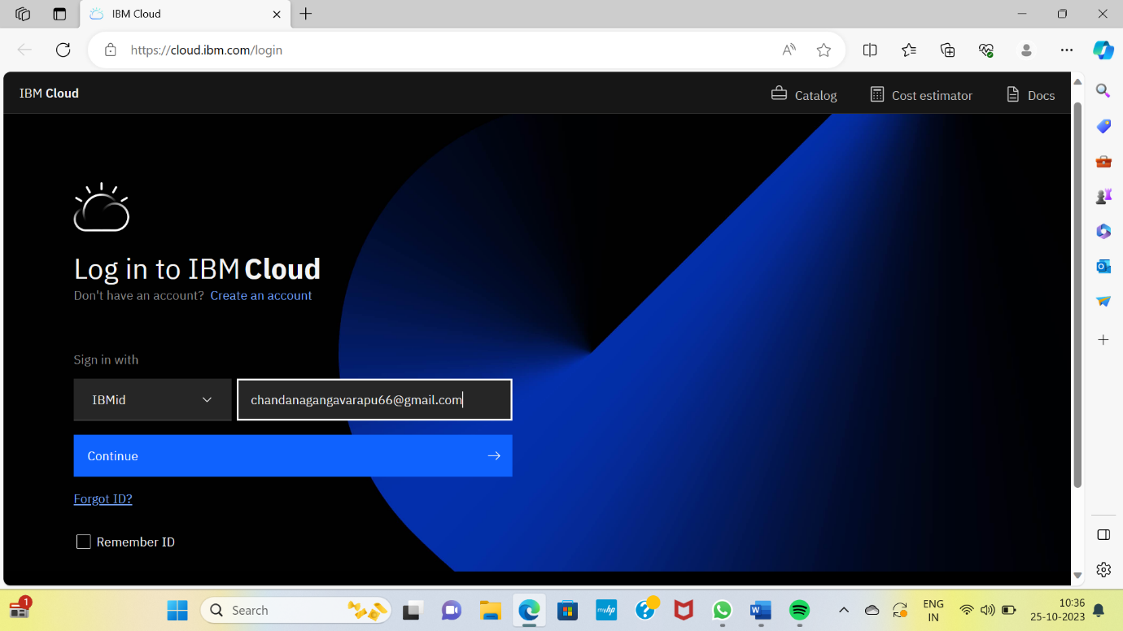

**Enter your password, then click login.**

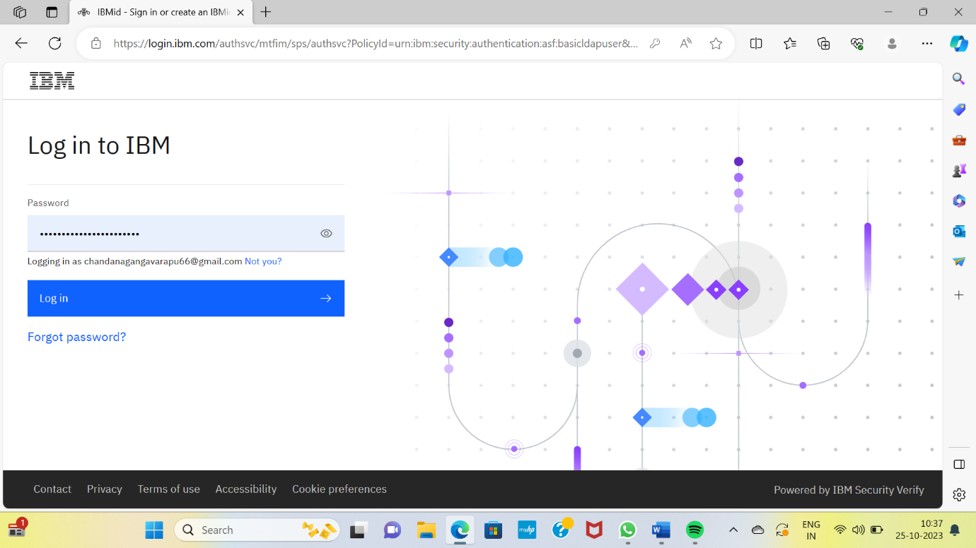**The homepage of the IBM account as follows:**

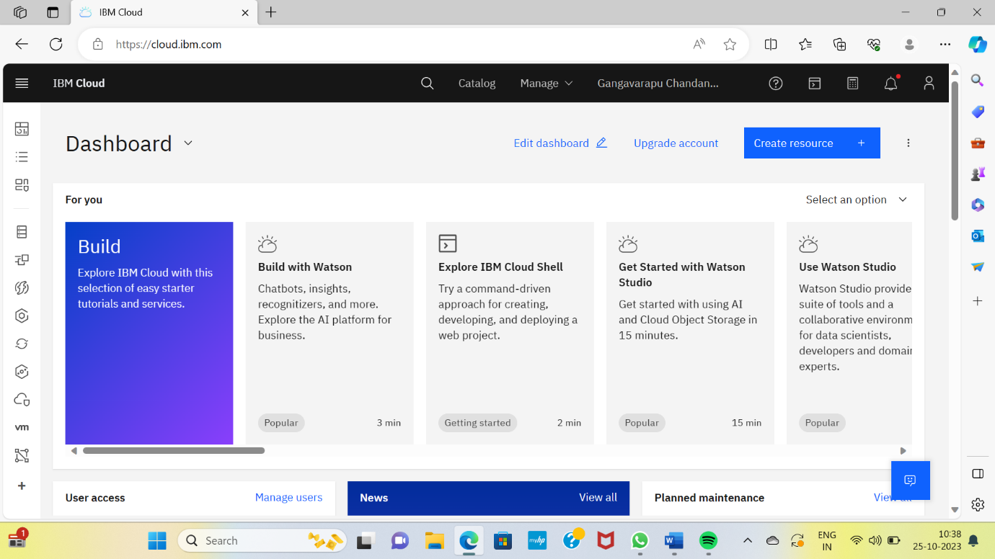

**Set up the Visual Recognition service, and obtain API keys.**

**Set up the Visual Recognition service:**

**Open the homepage of your IBM account.**

**Click on the manage :**

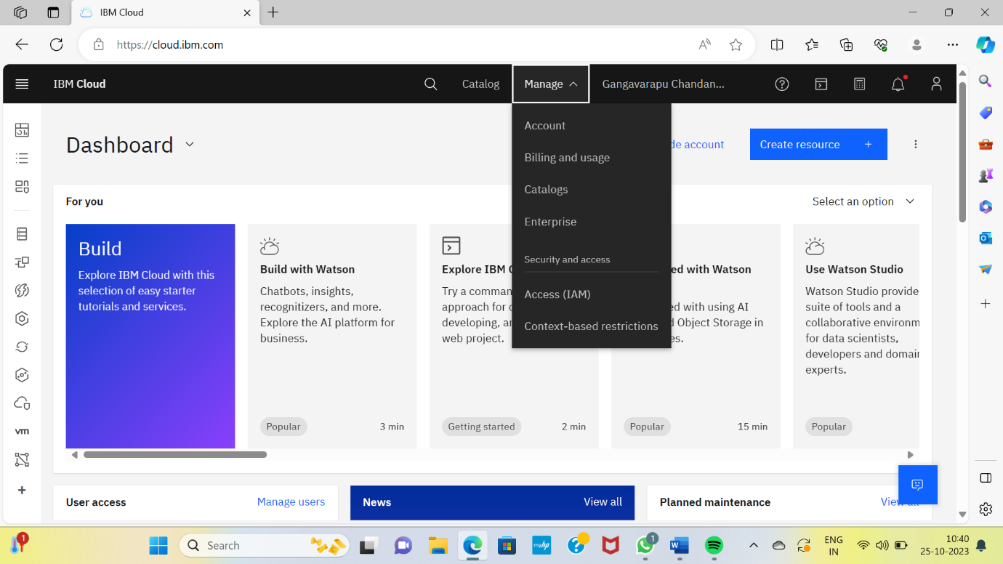

**Click on the Access(IAM) :**

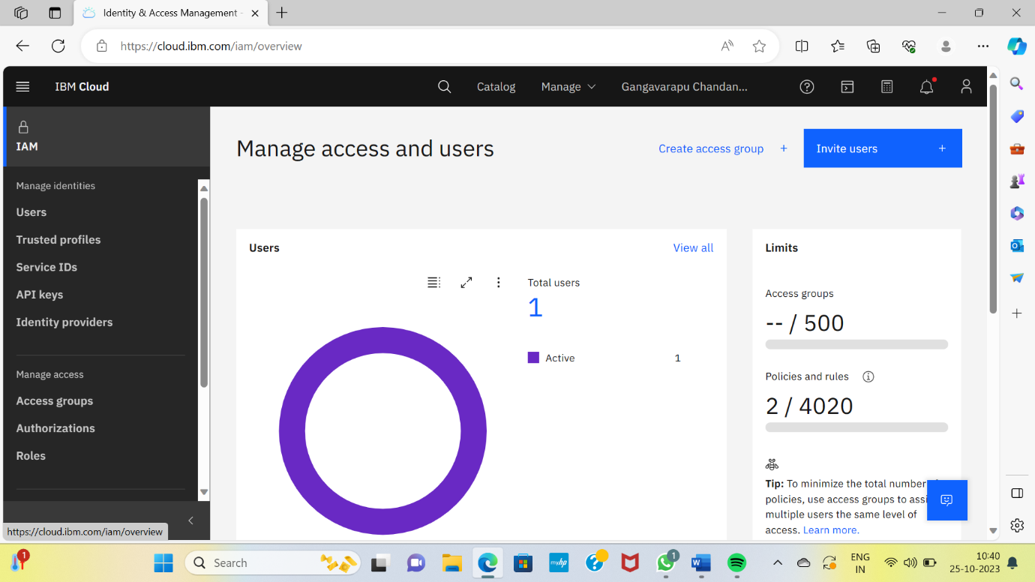**Then click on the Service IDs :**

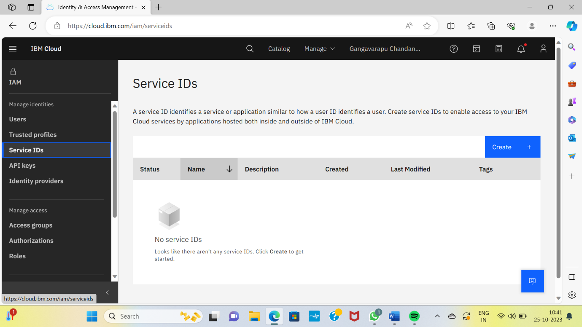

**Click on Create button, to create the service :**

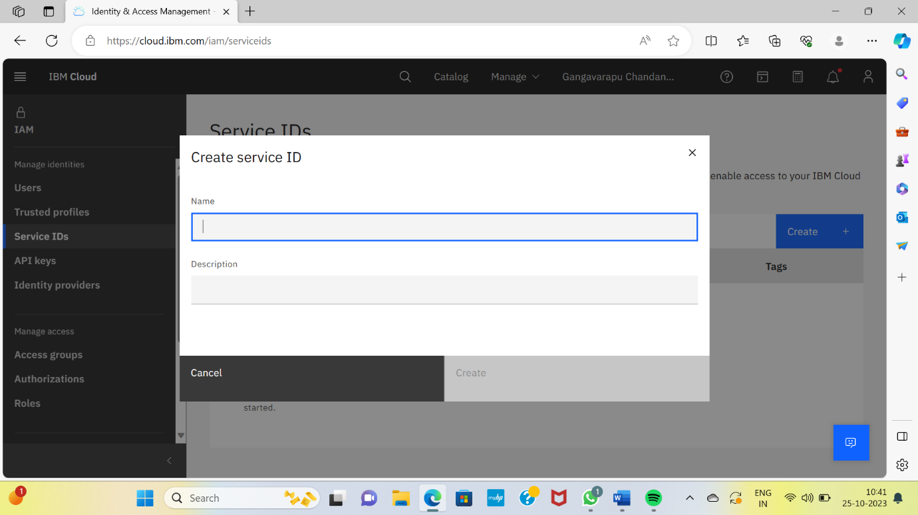

**Enter the name and the description for the service, then click on Create button to create the service :**

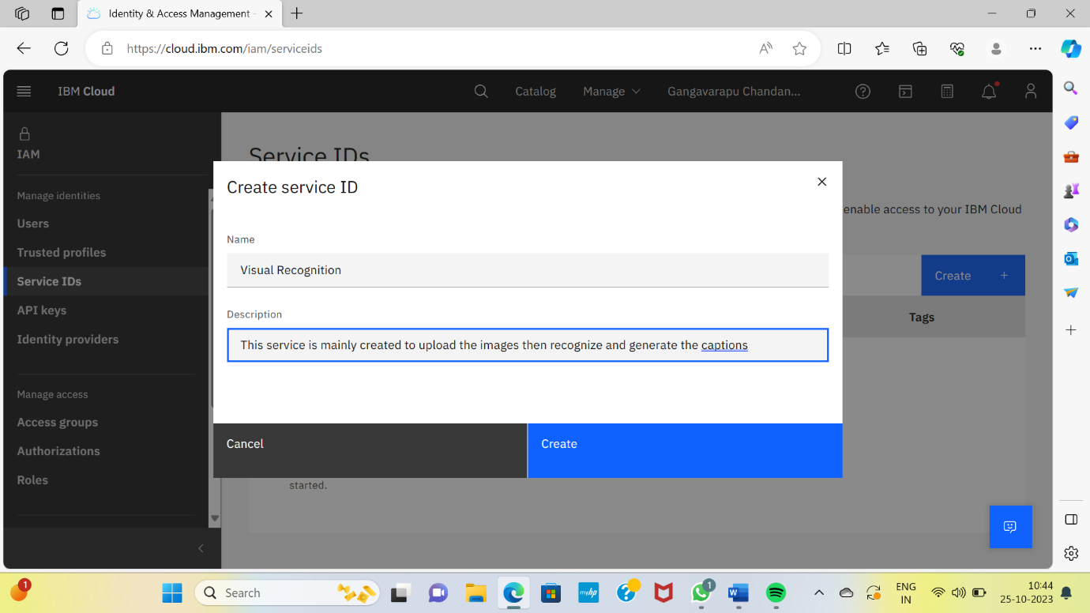

**Visual Recognition service has been created :**

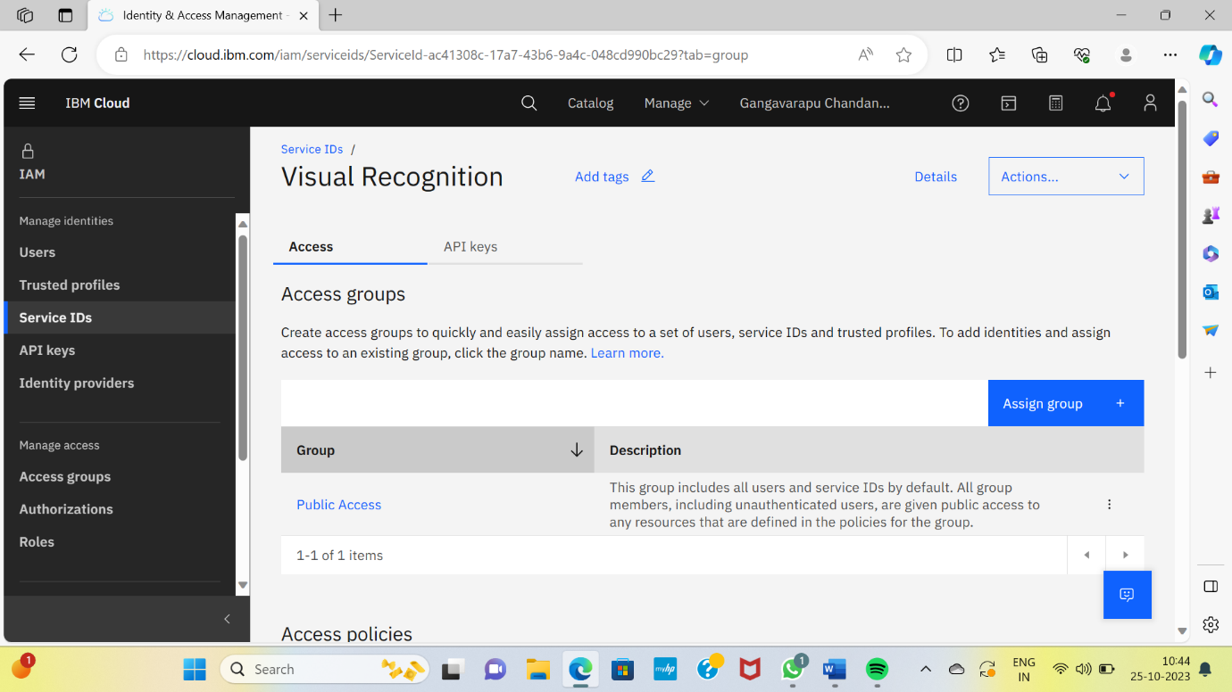

**Then click on the API keys, to obtain the API key for the Visual Recognition Service :**

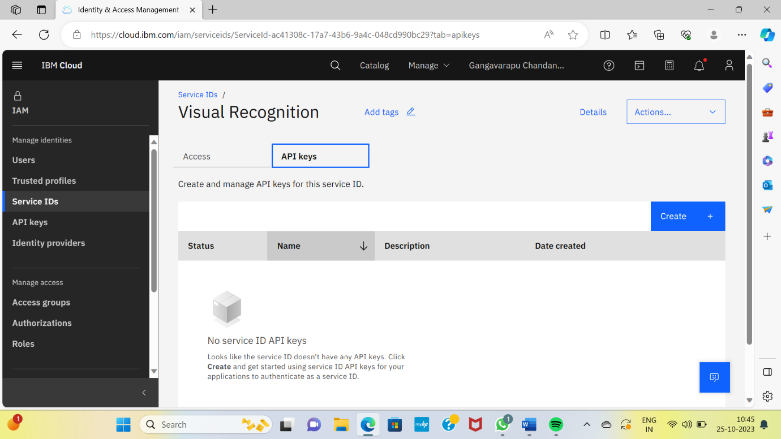

**Then enter the name and the description to create the API key and click on the Create button :**

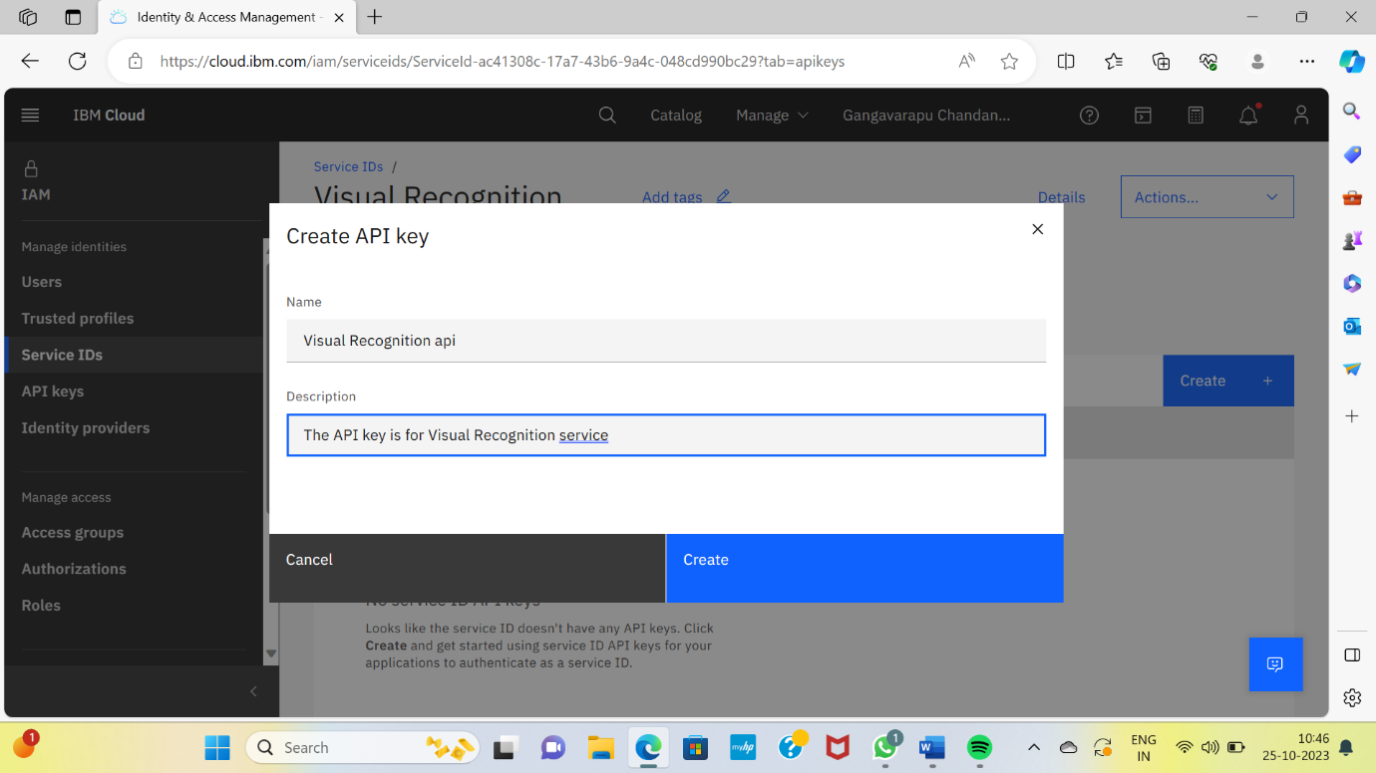**The API key has been successfully created for the Visual Recognition Service :**

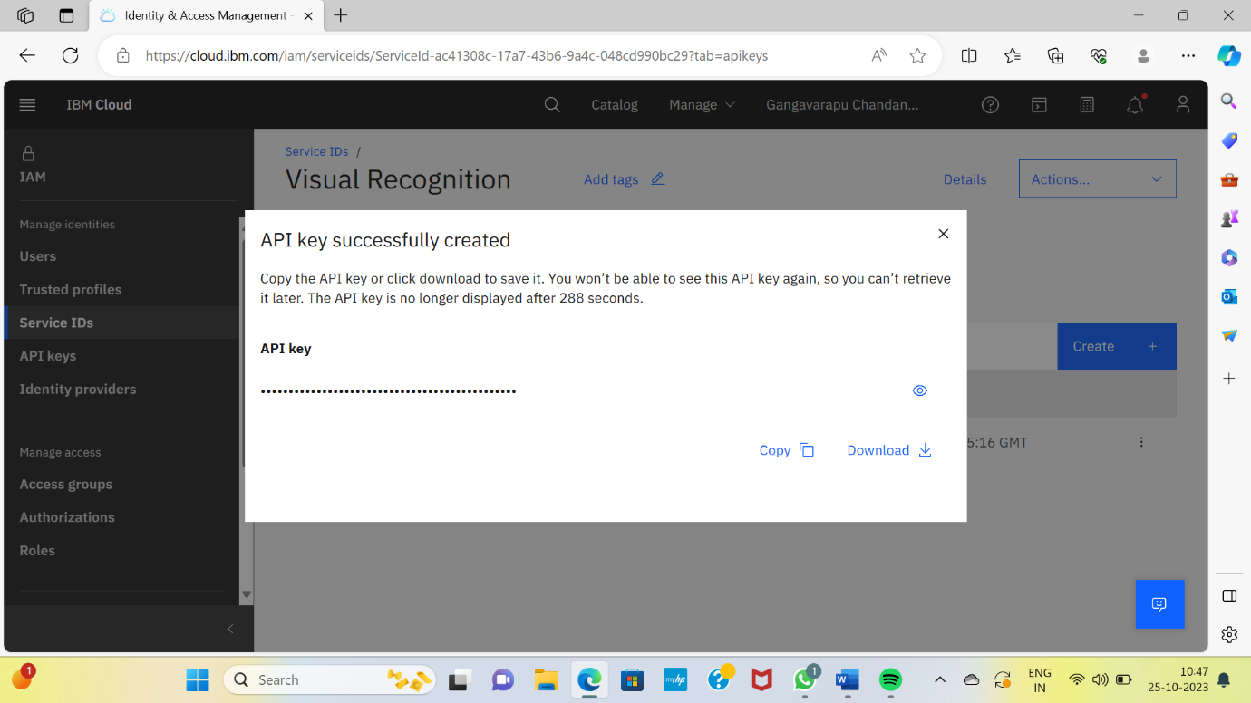

**The API key has obtained :**

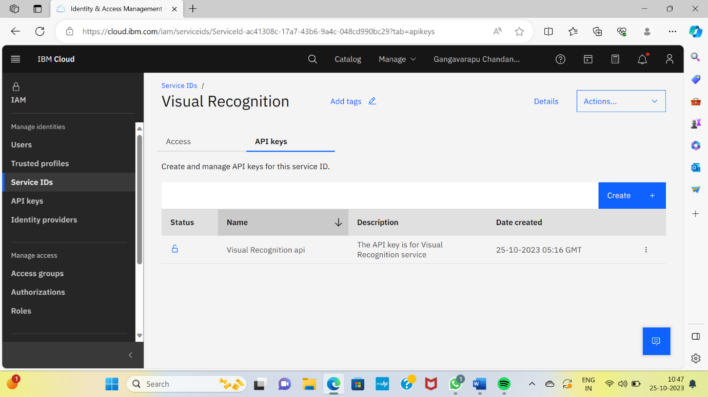**Visual Recognition Service document.**

Open the home page of your IBM account, click on the help :

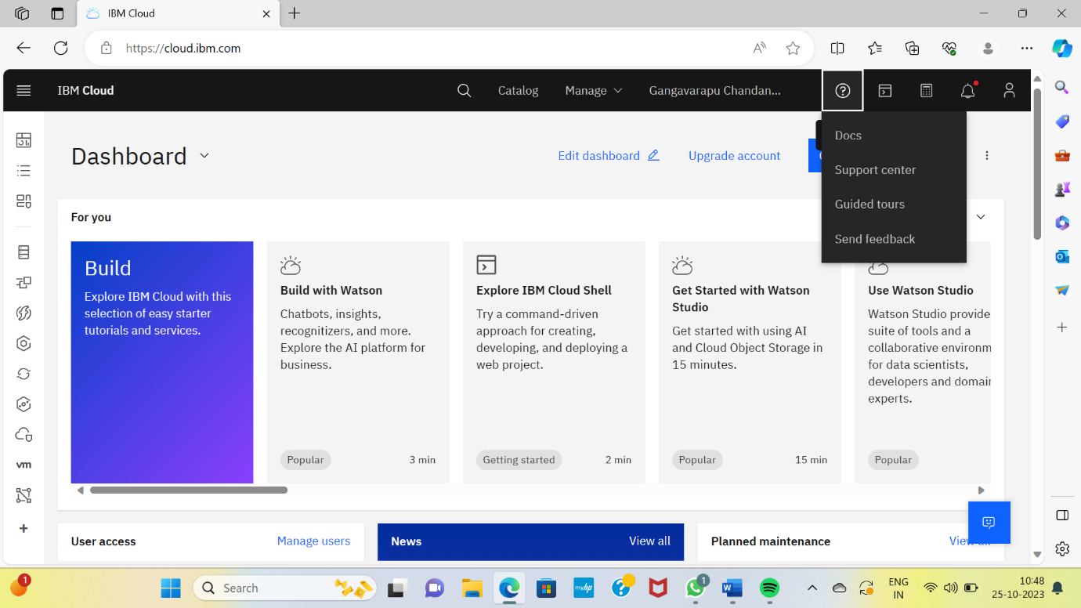

**Then click on the Docs to open the document of the Visual Recognition :**

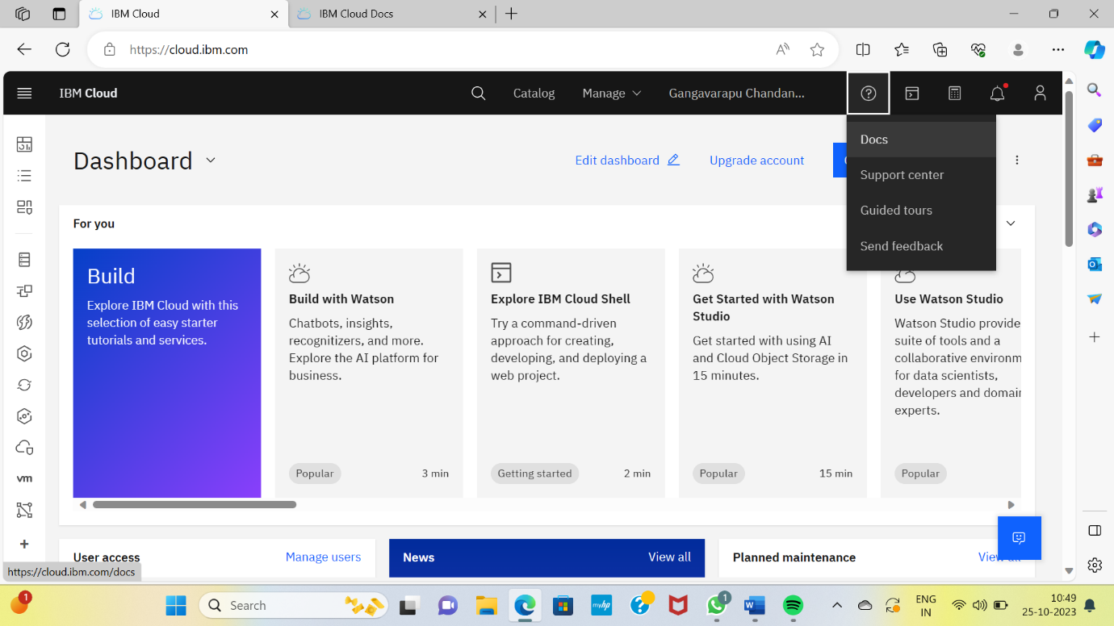

**Click on the search button at the drop-down menu, near the user account :**

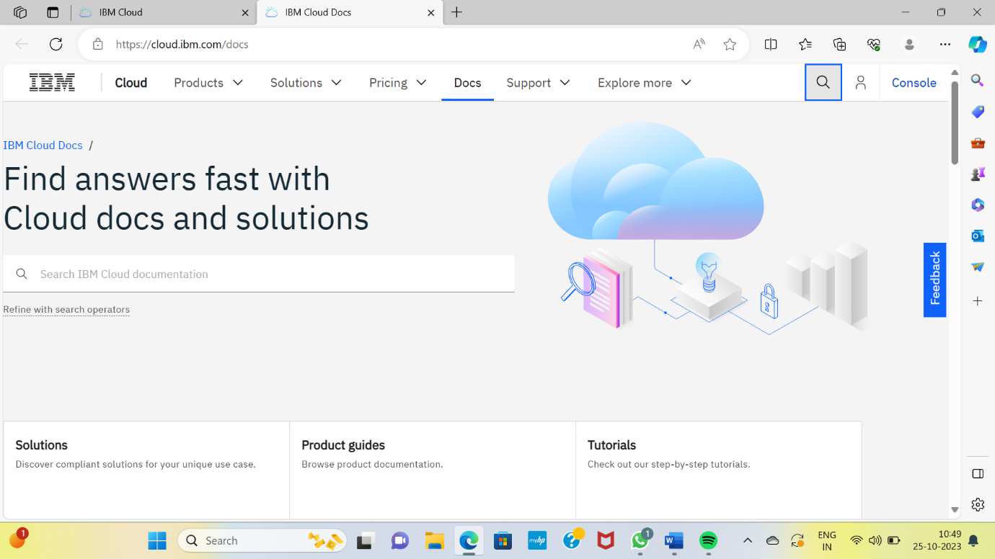

**Then search for the Visual Recognition :**

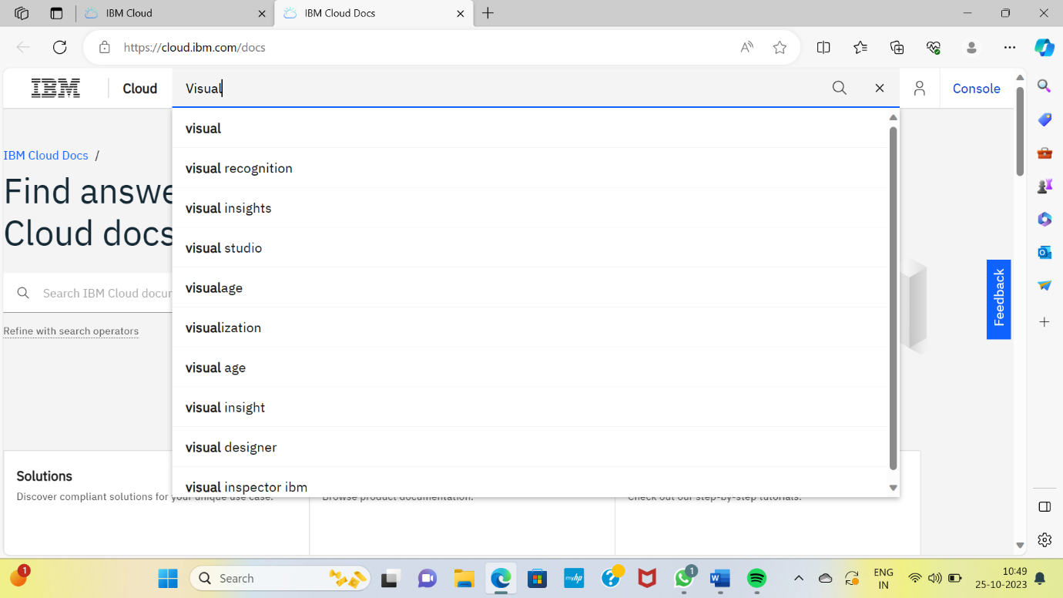**Open the DocumentAnalytics.VisualRecognitionClassifier actions :**

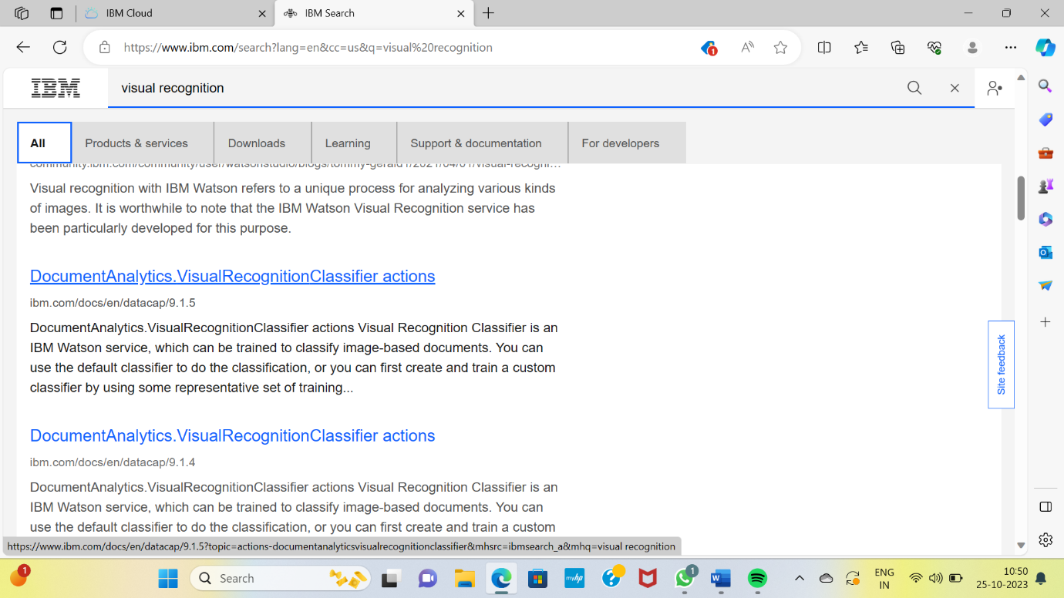

**The main page of the document as follows :**

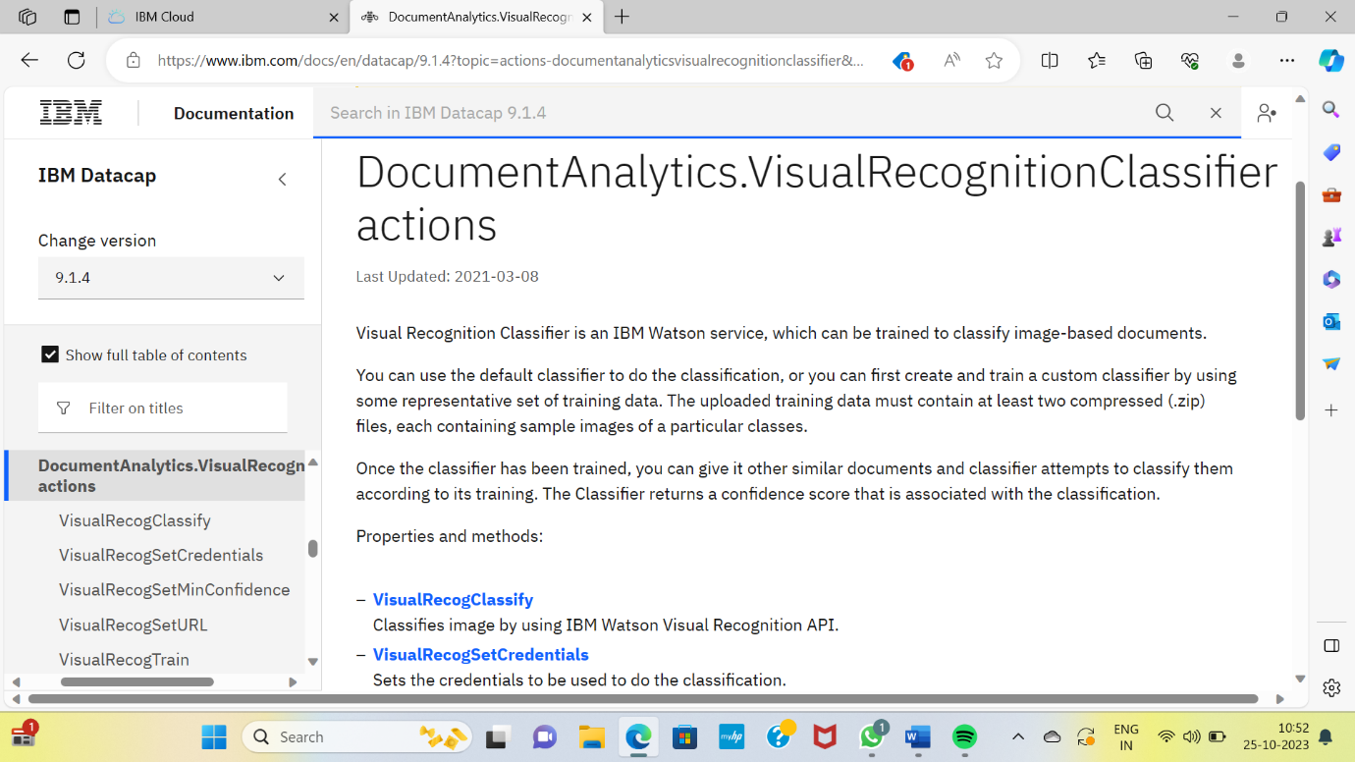

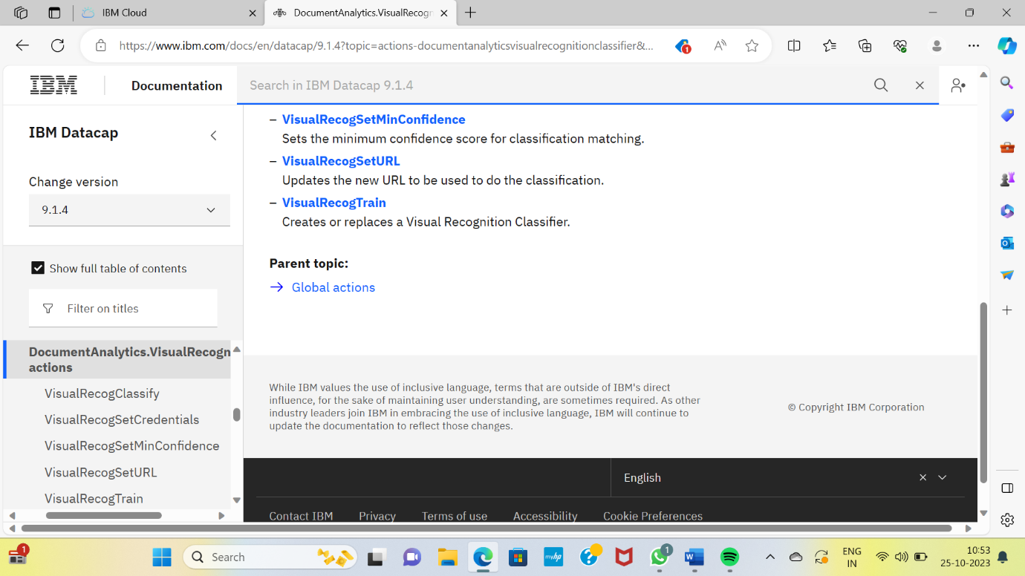

VisualRecogClassify:

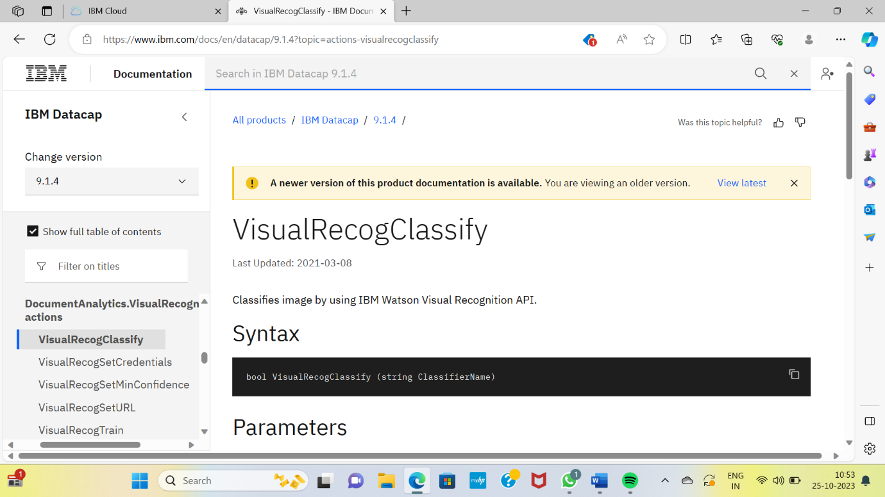

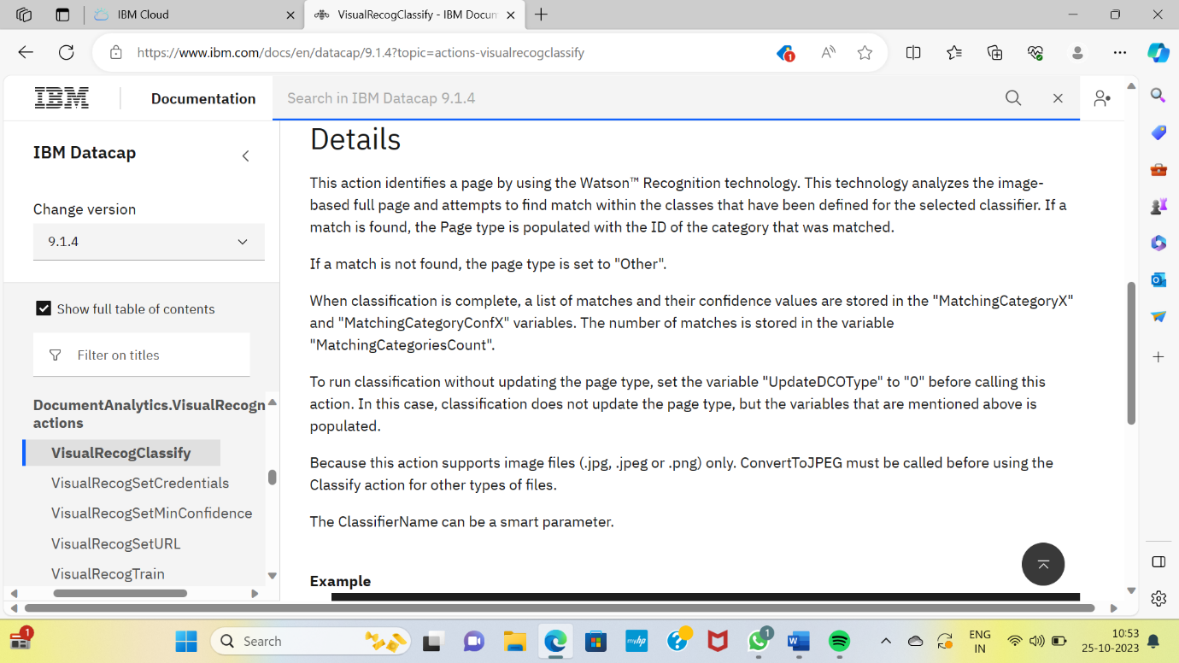

VisualRecogSetCredentials:

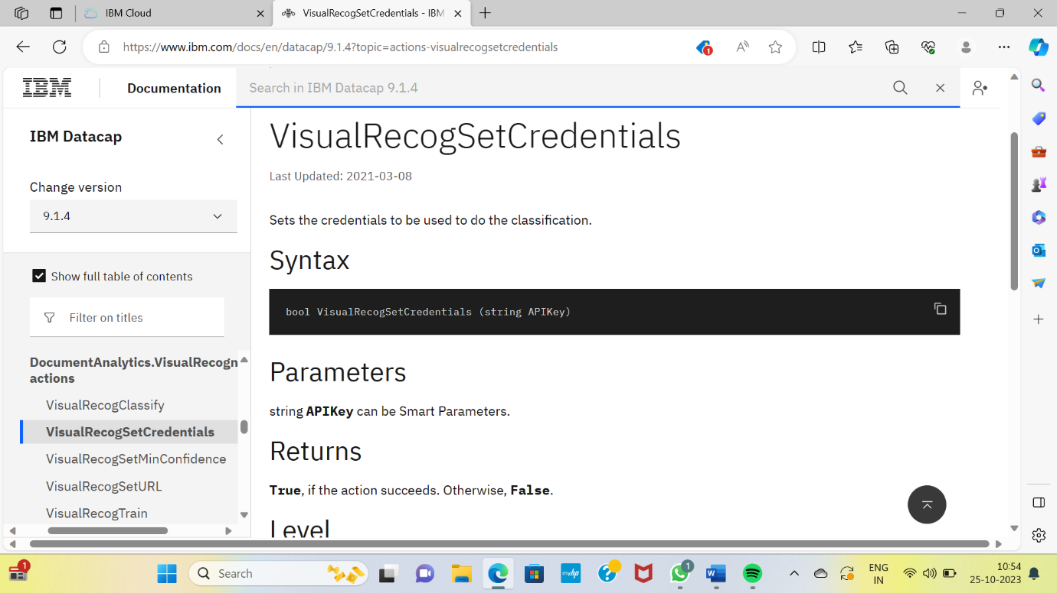

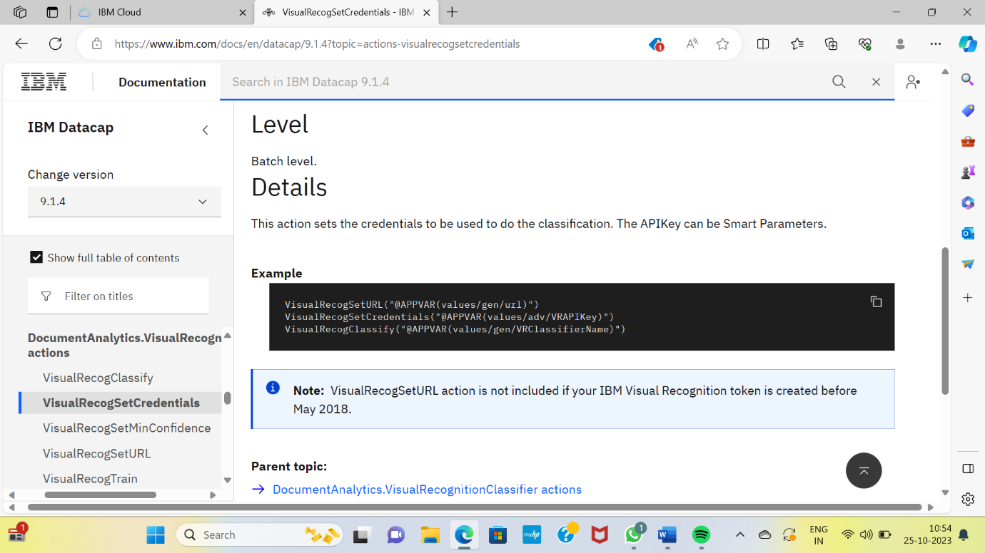

VisualRecogSetMinConfidence:

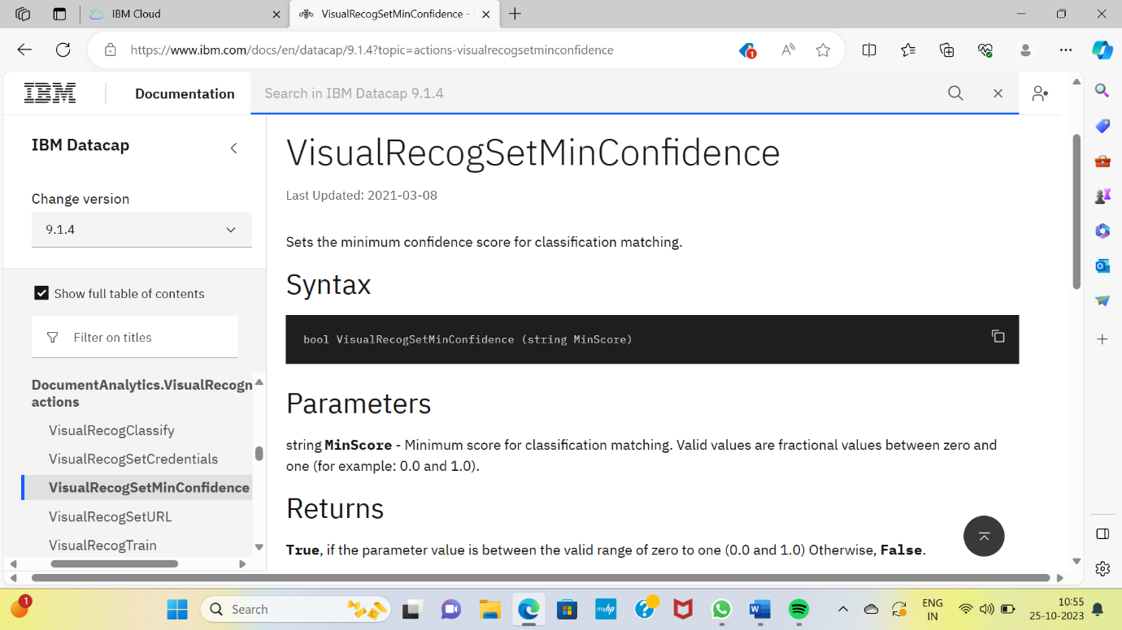

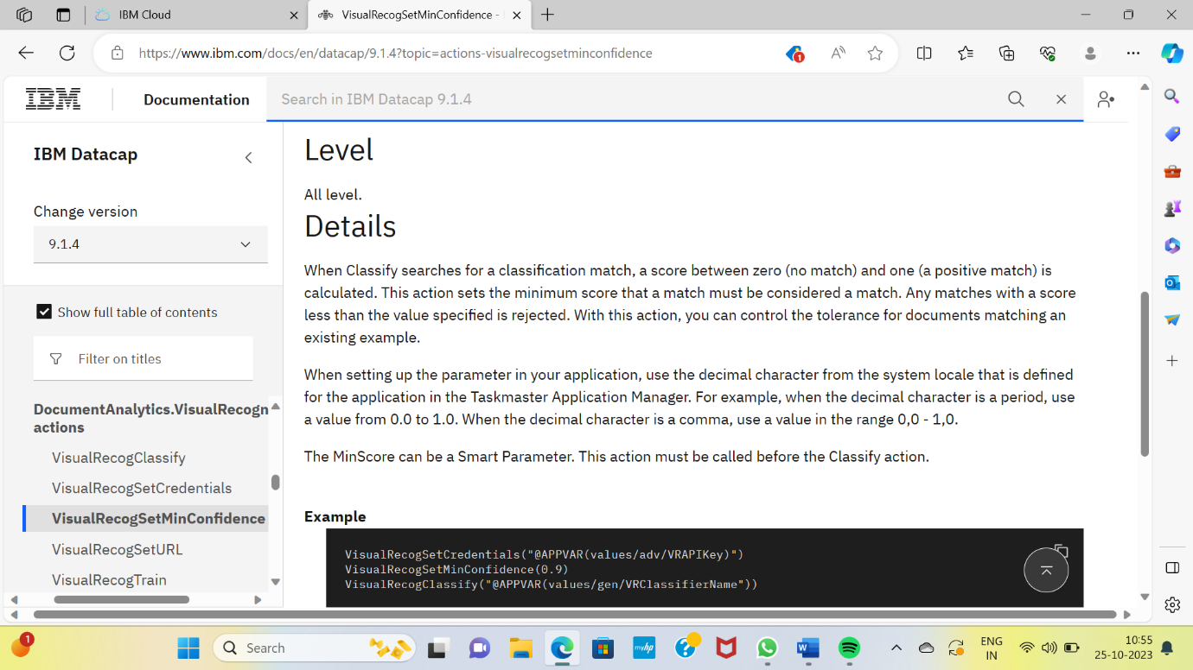

VisualRecogSetURL:

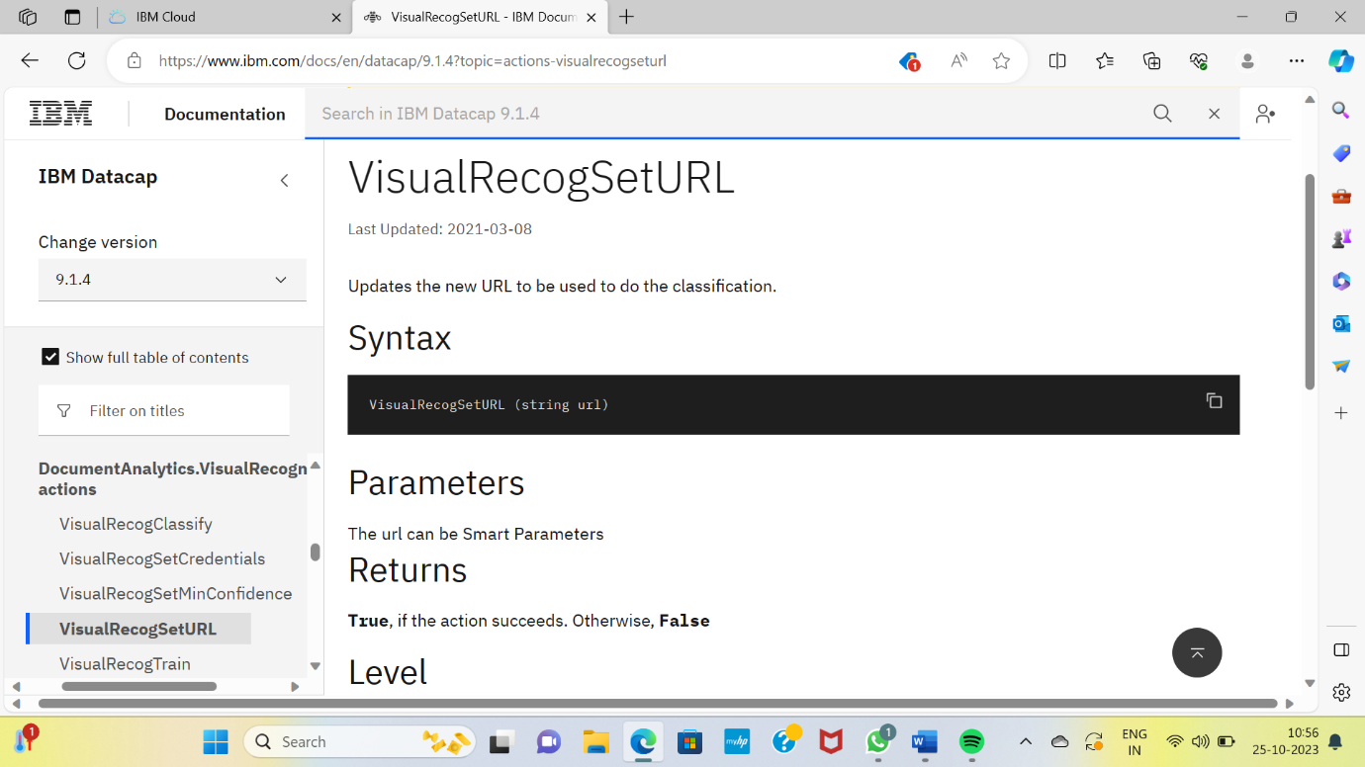

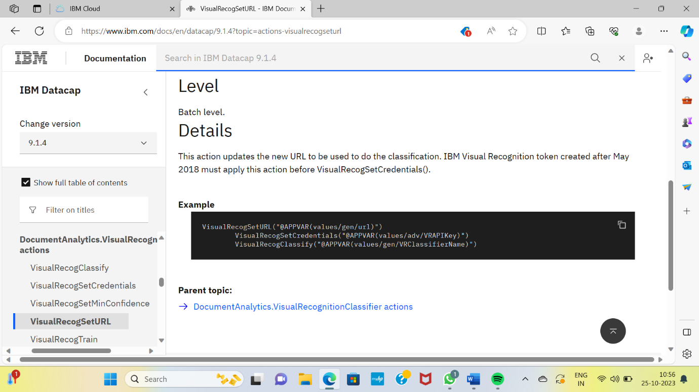

VisualRecogTrain:

